***Abstract:***

*In our project we employ methods of machine learning from text retrieval to search and build a workflow to troubleshoot a problem with a network based on previous similar errors in company database and what had been done to solve them providing more efficient day-to-day and long term work environment.*

*In addition the program will analyses the errors on time and configurational scale and advice on threshold adaptation to prevent future network issues and false alarms.*

**Keywords***: machine learning, Natural Language Processing, question answering machine, knowledge based artificial intelligence*

***INTRODUCTION***

The ability to automatically suggest an answer for a question given a database off possible previous occurrences of the question given to others is a focus of many studies in many fields.

The current status is as follows:

* All logs are examined manually by call center
* All work flows and troubleshooting are based on representative’s experience
* Existing, reoccurring and resolved errors are verified manually
* To analyze the Mellanox care Daily report - provide more work efficient environment.
* To timeline and analyze all previous site cases to identify reoccurring issue on port \ switch per customer.
* To synchronize and monitor any frequent alarms\ triggers to locate reoccurring issues with Mellanox products on all Mellanox care Sites
* To provide a day \ week statistics - threshold adaptation advise for each site.

The aim of this project is upon receiving a network error from a customer to analyze and build a multi-stage work flow to troubleshoot a certain network error using a machine learning algorithms (knowledge based AI).

It will be done by finding all correspondences with this error, retrieve comments in the correspondences between support engineers and customers from the company's database and identify helpful and unhelpful advices using Natural Language Processing (NLP) algorithms on both the engineer and the customer, parse the input by the customer and “score” the engineer’s reply, thus with machine learning algorithms suggest a multi stage work-flow based on high scoring answers for every stage and determining what high scoring directions should not be implemented, due to prior actions (fault isolation).

***Background and Related Work***

**Mellanox overview**

Mellanox Technologies is a leading supplier of end-to-end InfiniBand and

Ethernet interconnect solutions and services for servers and storage.

Mellanox offers a choice of fast interconnect products: adapters, switches, software and silicon that accelerate application runtime and maximize business results for a wide range of markets including high performance computing, enterprise data centers, Web 2.0, cloud, storage and financial services.

**Mellanox Call Center**

Mellanox Call Center provides permanent manned support services for Mellanox customers throughout the year (7/24/365) based on the appropriate support contract.

The Call Center is the customer’s point of contact (mostly for emergency cases) for initiating and advancing technical related and support administrative issues.

Call Center activities are designed to accomplish the following targets:

1. Provide systematic and efficient call handling services to Mellanox the customer.

2. Maintain information flow according to developing situations.

3. React to cases according to predefined procedures.

**Mellanox's online Customer:**

Mellanox's online Customer Resource Management (CRM) system – SalesForce, provides a comprehensive online tool to manage all of the customer's support issues in one place.

1. Complete case management including reporting support issues and tracking their progress.

2. A searchable knowledge database to find solutions, best practices and worthy information

3. Access to documentation and drivers/firmware/software downloads

4. Built-in RMA request and tracking system.

**Mellanox Care – Proactive Care Platform:**

24/7 fabric management services provided by Mellanox networking experts

Mellanox Care services use a combination of advanced monitoring software with a 24/7 human expert service of Mellanox personnel.

Mellanox Care will identify – **Keep alive Events** that will alert and address hardware failures, non-optimal configuration, service degradation issues and more. Above and beyond keeping the fabric healthy, Mellanox Care identifies and addresses the more complex performance issues and bottleneck scenarios, which are impacting application performance.

**Unified Fabric Manager (UFM®) Software for Data Center Management:**

Mellanox’s Unified Fabric Manager (UFM®) is a powerful platform for managing scale-out computing environments. UFM enables data center operators to monitor, efficiently provision, and operate the modern data center fabric. UFM eliminates the complexity of fabric management, provides deep visibility into traffic and optimizes fabric performance.

**Mellanox 911 process for urgent \ fatal issues:**

Company 911 procedure set to establish communication and urgency for customer’s issue.

Meant to ensure that proper attention of Mellanox functions, SLA target is met and to raise the awareness of related account teams and other professional groups (OPS, PM, AE, OEM account team, etc.)

Company 911 process will trigger upon the following events

* Customer in Gold or Silver service and a Fatal or network down situation.
* Design-in customer with Fatal-level issue concerning a showstopper with a technology-integration
* Product Manager Account with Fatal-level issue concerning a showstopper with technology-integration or production down.

**Mellanox Daily Report:**

Mellanox Daily Report is a snapshot of the environment it is running on that collects all the relevant information on Mellanox products installed.

It contains the following reports:

* **UFM Health Report** that summarize the following :

UFM Configuration, UFM Processes, Memory Monitoring, CPU Monitoring, Disk Monitoring, Fabric Interface, Core Dumps List.

* **Fabric Health report** for quick deployment and maintenance analysis for the following:

SM Status, Bad Links, Link Width, Link Speed, Firmware Versions, Signal Integrity ,Cable Info, UFM Alarms

**Example:**

Fabric_Health.html

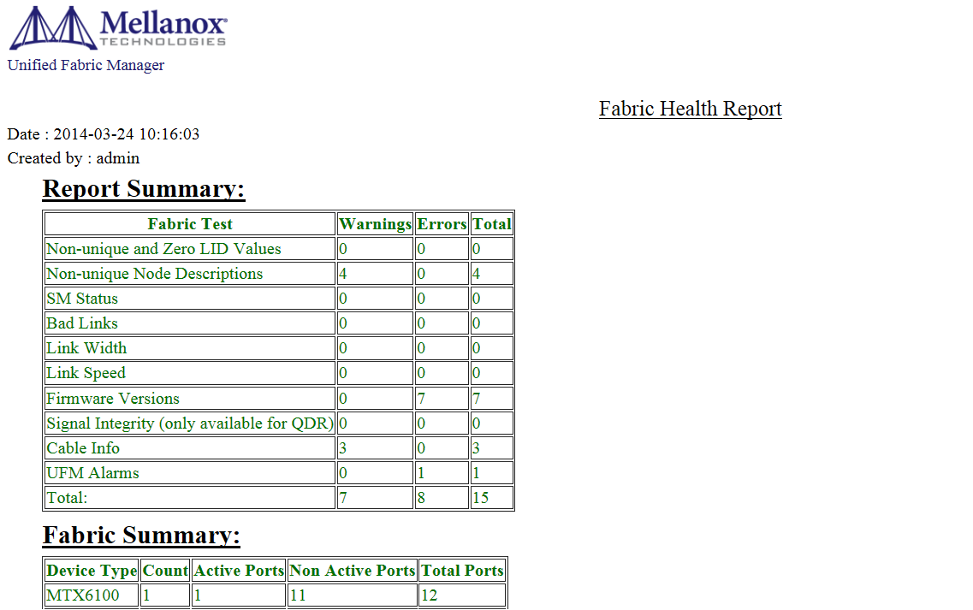

**Mellanox Care Policy Booklet:**

Mellanox Care Booklet list all possible events captured by Mellanox Care application

For each event you will find the following attributes:

* Description.
* Code.
* Final open case (Yes for all events in Booklet)
* Category (Device management, Fabric management, etc.).
* Related items/Potential root cause.
* Description of error – in detail.
* First Line Support corrective actions.
* Support type/process (Standard/Fatal).
* Fatal – triggers 911 process.
* Standard – redirected to First Line Support 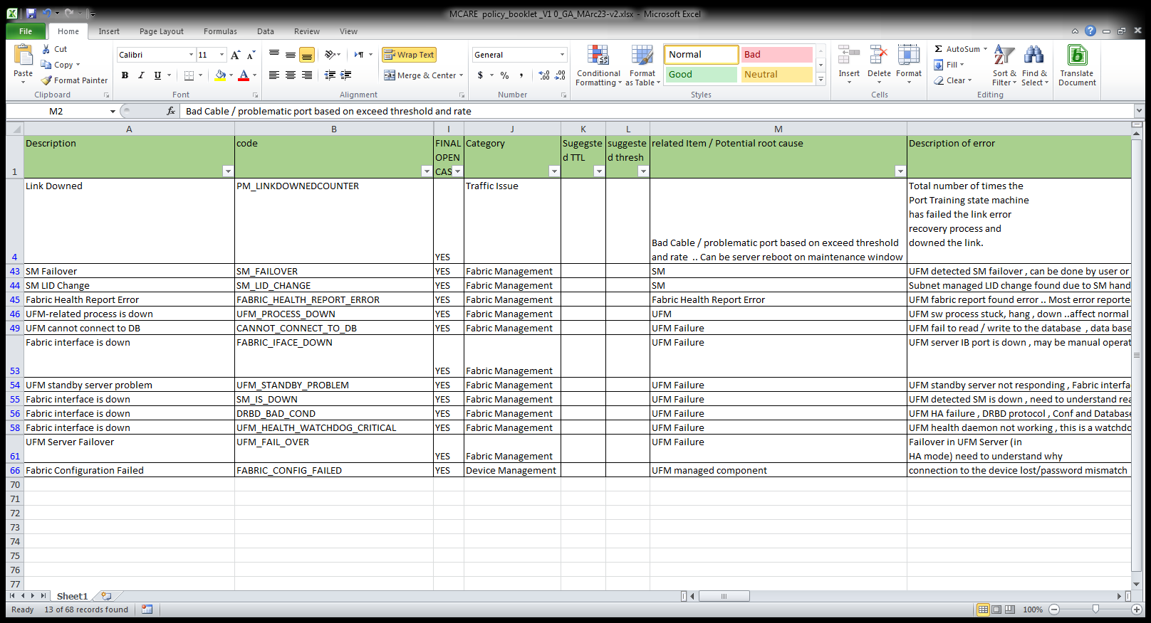

**Summary of Booklet solutions**:

1. Activate 911 process.
2. Collect switch dump from switch.
3. Collect snapshot from server.
4. Collect ibdiagnet logs – scans the fabric using directed route packets and extracts all the available information. Regarding its connectivity and devices. It then produces the following files in the output directory.
5. Check connectivity with master UFM
6. Collect UFM logs. – show UFM status.
7. Check if this is manual operation. ( intended )
8. Replace cable.
9. Reset cable.
10. Troubleshooting steps for faulty card.
11. Troubleshooting steps for faulty switch.
12. Check user name pass setting.
13. Delete the extra license remain with single license.
14. Provide description of error explanation.

**Introduction to Machine learning - Case-Based Reasoning**

The work of Roger Schank, is widely held to be the origin of CBR. He proposed a different view on model-based reasoning inspired by human reasoning and memory organization: If a “memory packets” contains a situation where some problem was successfully solved and the person finds himself in a similar situation, the previous experience is recollected and the person can try to follow the same steps in order to reach a solution. Thus, rather than following a general set of rules, reapplying previously successful solution schemes in a new but similar context solves the newly encountered problems.

In the problem solving algorithm of case based reasoning the following steps are taken:

* Describing the current problem.
* Searching for a similar previously solved problem.
* Retrieving the solution to it.
* Adapting the solution to the current problem.
* Verifying the solution.
* Storing the newly solved problem.

In turn, since the newly found solution may be used for solving future problems, the process denotes the CBR working cycle.

***Machine learning***

Machine Learning is the wish to program computers so that they can “learn” from input available to them. The input to a learning algorithm is training data from our company’s database in which stored all technical issues that was dealt over the years, and the correspondences are representing experience which can the program learn in order to advise to a novice support engineer.

To find the best way to do this we’ll have to be more explicit about what data our programs will access, how they parse it, how and when the learning process will be done and will it be evaluated.

The most popular formal approaches to machine learning applicable to our project are as follows:

**Supervised learning**

Algorithms are trained using labeled examples, such as an input where the desired output is known. In our project, for example, an answer by an engineer to a customer’s reply could have score points labeled from 0-10, based on previous cases. The learning algorithm receives as an input the reply from the customer to this answer and the algorithm then learns how good it was based on customer’s next reply and modifies the model (score and stage) accordingly.

**Unsupervised learning**

It is used against data that has no historical labels. And they have no scoring points for a data set. The goal is to explore the data and find some structure within. In our project it can identify customers with similar issues who can then be treated similarly or point out a large scale problem from many costumers.

Popular techniques include self-organizing maps, nearest-neighbor mapping, k-means clustering and singular value decomposition. These algorithms are also used to segment text topics, recommend items and identify data outliers.

**Semi-supervised learning**

It is used for the same applications as supervised learning. But it uses both labeled and unlabeled data for training – typically a small amount of labeled data with a large amount of unlabeled data .This type of learning can be used with methods such as classification, regression and prediction.

**Reinforcement learning**

It is often used for robotics, gaming and navigation. With reinforcement learning, the algorithm discovers through trial and error which actions yield the greatest reward. In our project, the goal is to find solution to the problem the costumer is facing in the shortest amount of replies, minimizing the time effort and cost by the customer. If the decision making process reaches the goal much faster by following a good policy that not follows the current score the model need to be modified. So the goal in reinforcement learning is to learn the best policy.

**Decision Trees**

It is one of the most widely used and practical methods for inductive inference. It is a method for approximation of discrete-valued functions, in which a tree represents the learned function. Each node in the decision tree specifies a test of some attribute of the query instance, and each branch descending from that node corresponds to one of the possible values for this attribute. In our project, a positive or negative answer by the customer to any of the engineer’s questions in the previous stage (that was preferably generated by this app as well to follow this tree) will eliminate many other troubleshooting steps and may focus on other, more specific, test to find the root cause of the error.

**Formal definition of AI Implantation**

**Sensors:**

The support engineer.

**Actuators:**

Suggest a multi stage work-flow based on high scoring answers for every stage and determining what high scoring directions should not be implemented, due to prior actions (fault isolation).

**Procedure**:

// this is reserved for the scoring algorithm.

**Percept**:

Booklet, comments from cases, case resolution, snapshot, switch system logs

**Natural Language Processing (NLP)**

The idea of computers being able to understand ordinary languages human is being a focal point of scientific studies for many years, in our project we deal with customers from all around the world so when taking in consideration that people from around the world communicate in various ways, and have different ways of expressing themselves and not only do individuals but also people from other countries tend to make choices may be more characteristic. When add to that is the challenge of “English as a second language”, we will fully appreciate the challenges posed by understanding of natural language and even achievements from focusing on a range of specific fields which will be determining what is a positive or a negative response by a customer.

**Tokenised text and pattern matching**

One of the more basic operations that can be applied to a text is tokenising: breaking up a stream of characters into words, punctuation marks, numbers and other discrete items: a fair amount of information may be obtained from relatively shallow analysis of tokenised text for example negative words like “no” didn’t help” may reveal that the reply by the engineer wasn’t helpful while “expressions like “issue resolved” “thanks for the help” may indicate the it was helpful. In addition, we need to pay attention to some aspects that may reveal that the customer is not satisfied such as the text is written with all capital letters or there are numerous or more than two consecutive exclamation marks. The emotional aspects of the language may vary from language to language.

**Parts of speech and structure**

A further stage in analyzing text is to associate every token with a grammatical category or part of speech (POS). In our project we will have to analyses the grammar of the sentence to determine on the type of the response, such as: “we solved the issue”, “the issue was solved” “your solution was helpful” etc.

***Design (GUI, UML diagrams)***

***Activity Diagrams:***

**Activity- Mellanox Care Daily report**

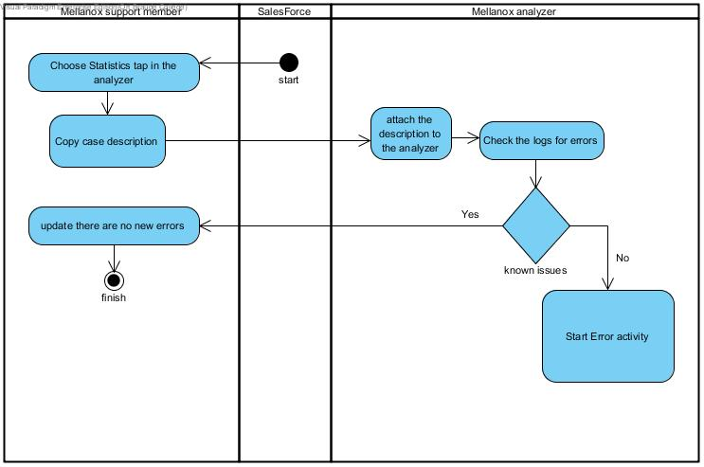

**Activity - Handle Error**

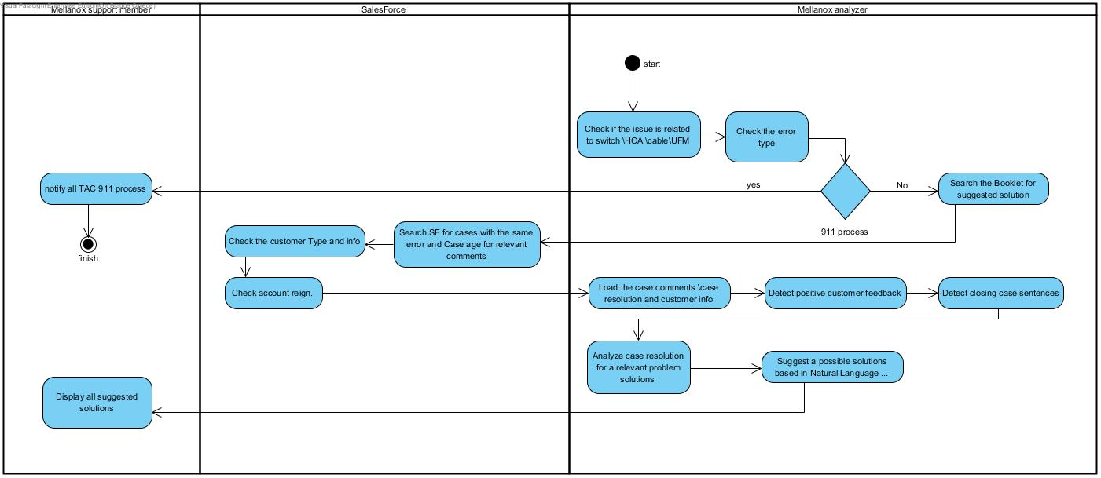

**Activity - Mellanox Care Keep alive event:**

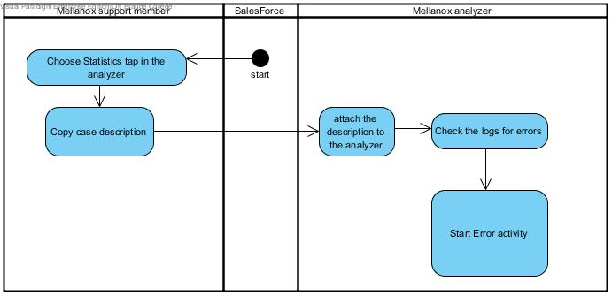

**Activity- Show statistics**

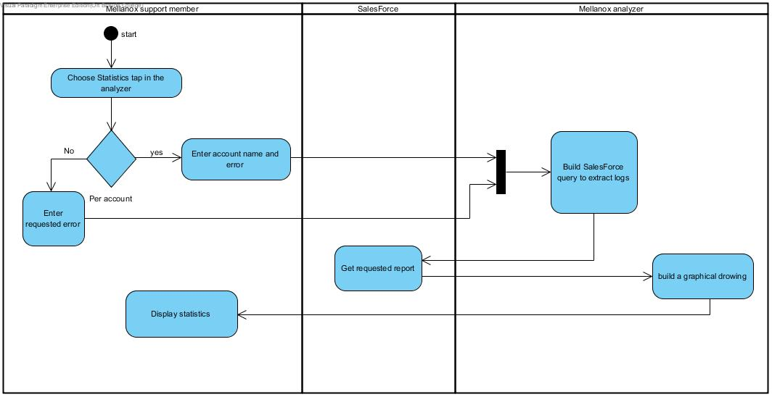

**Connection Diagram:**

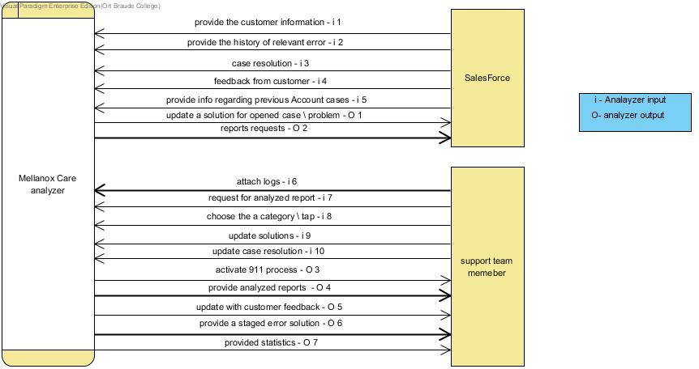

**Case Diagram:**

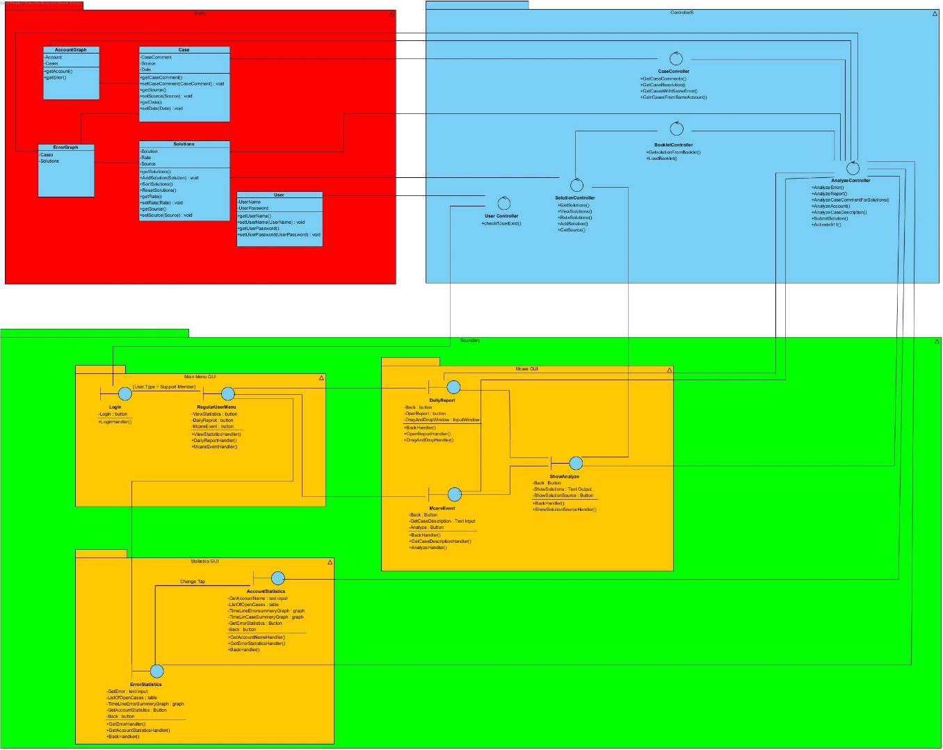

**Data Flow Diagram:**

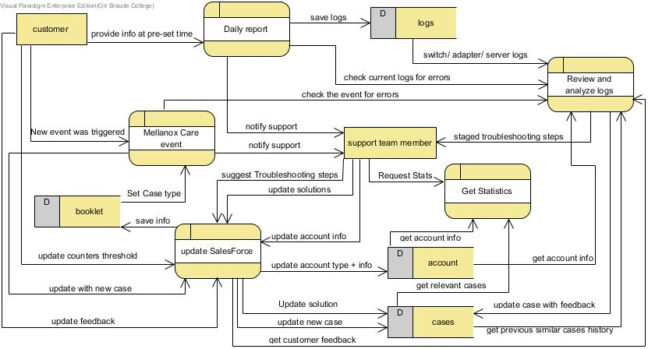

**Testing plan**

We will implement our approach in the context of the alarm triage problem submitted by a customer. Our simulation experiments with data from many previous cases in which the troubleshooting steps by the engineers are different and the responses by the customer are different. We will add new engineers replies and new customer responses to show the potential of our constantly-updating machine-learning-based approach for improving the error triage and troubleshooting process.